ETL SCD2 with DBT & Snowflake
Objective: Demonstrate the process of SCD2 (Slowly Changing Dimension type 2). SCD2 allows for a record to be updated in a table but keeps the old record (row) and adds a new record(row) with updated information. A value is added to old record such as end_date and/or is_active to signify the previous record.
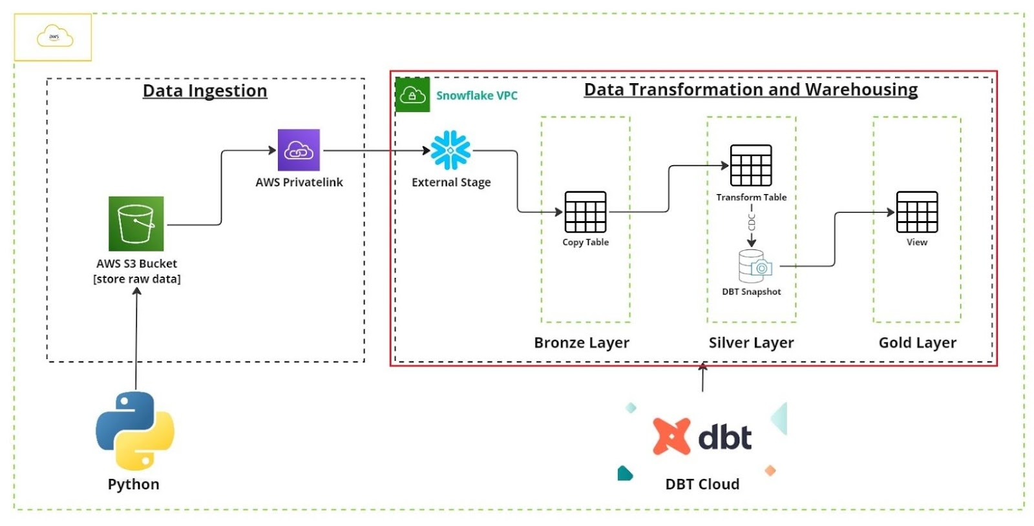

Process: For this project I will demonstrate data being uploaded to S3 using python script which is then ingested through snowflake external stage.
- Data uploaded to S3 using python script using AWS CLI in VS code. Snowflake picks up data from S3 external stage.
- A macro inside DBT allow for the data in stage to be copied into raw table at the bronze layer.
- Data is then transformed in silver layer using DBT. During this stage, a DBT snapshot is created to allow for the SCD2 logic to take place, using a ‘check’ strategy.
- A view is created in gold layer to view transformed data
- If a change is made in the source data, such as, (making a change in the csv file and uploading it again), then we re-run the silver layer model to transform the data. Then we run the snapshot command on transformed data to produce the new data in the gold view.
Below is lineage for DBT:
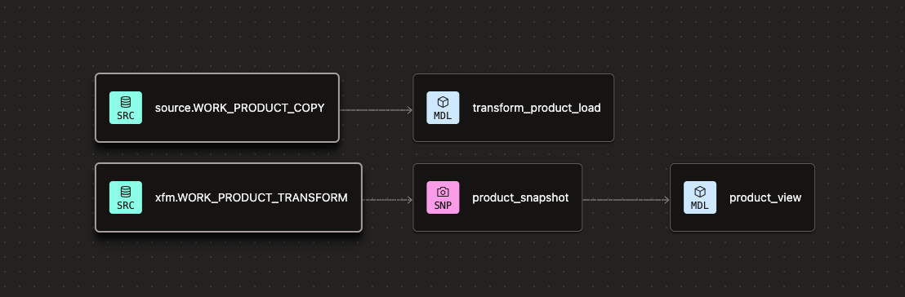

Snowflake tables and schemas:
